If desired paste Consultant logo here

Data Center Energy Analysis Report

for

[INSERT PROJECT NAME and ASSIGNED ENERGY TRUST PROJECT ID NUMBER]

Submitted by

[INSERT CONSULTANT NAME HERE] "Consultant"

on behalf of

[INSERT PROJECT OWNER'S NAME AS SUBMITTED TO THE PROGRAM IN FORM ___ HERE]
"Project Owner"

to

Energy Trust of Oregon
New Buildings Program

Submittal Date: [INSERT DATE]

Project Contacts

Project Owner
Contact Name
Company
Address
P: (xxx) xxx-xxxx
F: (xxx) xxx-xxxx
E: xxx@xxx

Architect
Contact Name
Company
Address
P: (xxx) xxx-xxxx
F: (xxx) xxx-xxxx
E: xxx@xxx

Mechanical Engineer
Contact Name
Company
Address
P: (xxx) xxx-xxxx
F: (xxx) xxx-xxxx

Commissioning Agent
Contact Name
Company
Address
P: (xxx) xxx-xxxx
F: (xxx) xxx-xxxx

Energy Consultant
Contact Name
Company
Address
P: (xxx) xxx-xxxx
F: (xxx) xxx-xxxx
E: xxx@xxx

General Contractor
Contact Name
Company
Address
P: (xxx) xxx-xxxx
F: (xxx) xxx-xxxx
E: xxx@xxx

Electrical Engineer
Contact Name
Company
Address
P: (xxx) xxx-xxxx
F: (xxx) xxx-xxxx

Table of Contents

1 Summary 1
2 Project Description 2
2.1 Building Description 2
2.2 Early Design and Other Technical Assistance Activities 2
2.3 IT Loading 2
2.4 Project Phasing 2
2.5 Baseline Systems 2
2.5.1 Data Center Cooling 2
2.5.2 Power Distribution 3
2.5.3 Lighting 3
2.6 Proposed Systems 3
2.6.1 Data Center Cooling 3
2.6.2 Power Distribution 3
2.6.3 Lighting 3
3 Summary of the Energy Efficiency Measures 4
4 Economic Summary 5
4.1 Summary of EEM Costs 5
4.2 Energy and Energy Cost Savings 5
4.3 Cost Effectiveness Analysis 5
5 Appendix 8

Summary
Provide a description of the project. Include the following information:
- A brief description of the facility (i.e., construction - new, major renovation, addition or tenant improvement, size, expected occupancy(s), intended use(s), and any unique characteristics);
- Energy efficiency goals;
- Other analyses completed with Technical Assistance incentives; and
- Energy efficiency measures (EEM) analyzed, with a brief description of each.
Complete Table 1-1 to summarize results from the energy modeling.

Table 1-1: Summary of Energy Savings

 | Total Electric Energy Use  (kWh) | Total Natural Gas Usage  (therms) | Electric Energy Savings  (kWh/yr) | Natural Gas Energy Savings  (therms/yr) | Total Energy Savings  (kBtu/yr) | Incr. Cost  ($) | Simple Payback Period  (yrs) | Savings  (%)
Baseline Model | 1,000,000 | 0 | - | - | - | - | - | -
EEM 1: description | 890,000 | 0 | 110,000 | 0 | 375,320 | $50,000 | 6.5 | 11%
EEM 2: description | 725,642 | 0 | 274,358 | 0 | 936,109 | $125,000 | 6.5 | 27%
EEM N: description | 962,000 | 0 | 38,000 | 0 | 129,656 | $2,500 | 0.7 | 4%
Proposed Model | 679,000 | 0 | 321,000 | 0 | 1,095,252 | $177,500 | 7.5 | 32%

Project Description
Provide an overall description of the project and building as well as any relevant information that is critical to the energy analysis.

Building Description
Provide a brief description of the facility. Include floor plan of the building areas included in the incentive application.

Early Design and Other Technical Assistance Activities
Describe other activities that received early design and/or technical assistance incentives. Include information on how the results of those studies informed or influenced the proposed design.

IT Loading
Discuss the anticipated loading on the plant.
- Current baseline assumptions include a utilization factor of 50% applied to the design IT load to account for redundancy within the data center design and server utilization rates that are significantly less than design/nameplate.
  - If the project proposes a utilization rate higher than 50%, supporting documentation should be provided.
  - In addition, discuss the daily, weekly, and/or monthly changes in loading. For example, some data centers may operate at a relatively constant loading across the day, while others may have higher operating loads during normal working hours and lower loads on nights and weekends.
- Identify any strategies for managing IT load (equipment efficiencies, storage optimization, power management, etc.).

Project Phasing
Discuss project phasing, including the timing of future phases.
- Identify equipment that is not anticipated to be installed in the first two years of operation.
- Provide timeline of load ramping, based on equipment installation and loading of installed equipment.

Baseline Systems

Data Center Cooling
Describe the baseline HVAC system, including relevant modeling inputs. Provide design IT density and discuss containment assumptions.

Power Distribution
Describe the baseline power distribution system.

Lighting
Identify lighting power density and controls applied to the baseline energy model. Provide scheduling and occupancy assumptions that affect lighting hours of operation.

IT and Networking Equipment
If efficiency measures associated with the IT and networking equipment are proposed, identify the baseline assumptions used to evaluate the savings associated with the efficiency measure.

Proposed Systems

Data Center Cooling
Describe the proposed HVAC system, including relevant modeling inputs. Describe proposed containment, supply and return air temperatures and humidity controls.

Power Distribution
Describe the proposed power distribution system, including proposed equipment efficiencies and any strategies for managing UPS loading.

Lighting
Identify lighting power density and controls in the proposed design. Provide information on how controls may affect assumed hours of operation.

IT and Networking Equipment
Describe the proposed IT and networking equipment, including proposed equipment efficiencies and strategies for minimizing load.

Summary of the Energy Efficiency Measures

Provide a summary of each EEM analyzed for the report. Each summary should include a description of the EEM and any details that will help the reader understand how the EEM operates and the source of the energy savings. Clearly indicate the comparison of pertinent details between the baseline and the EEM.

Examples:

- Reduction in lighting power density - Indentify how a reduction in the lighting power density (LPD) will yield energy savings. Provide a comparison between the maximum LPD(s) permitted by code and those of the proposed EEM for the project.

- High efficiency UPS– Summary shall address the baseline and proposed equipment efficiencies. Equipment efficiency at various loadings as well as strategies for optimizing loadings on the units to operate at peak efficiencies should be discussed. Redundant equipment should be included in the analysis to match actual operating load conditions.

Economic Summary
Use this section to identify the economics of the potential EEMs and include annual energy cost savings (gas and electric), incremental costs, simple payback periods, and the results of the Cost-Effectiveness Calculator test. The Savings Summary Worksheet should be used to generate the tables in this section. This tool is available at http://energytrust.org/library/forms/NBE_TL_SavingsSummaryWorksheet.xlsm. Instructions on how to use the tool are contained in the first worksheet tab labeled “Instructions”.

Summary of EEM Costs
Provide all the material, labor and equipment costs for the individual EEMs. The source of the included cost information must be identified.

Incremental labor costs can only be applied to EEMs in which the installation of the proposed EEM requires additional labor above that needed for the installation of the baseline system/component (i.e. labor for installing premium efficiency lighting or motors cannot be included), or in the case of an equipment upgrade during a renovation if the previous equipment had not reached the end of its useful life.

A table, similar to Table 4-1, must be included, providing an estimate of incremental costs for each of the investigated EEMs

Energy and Energy Cost Savings
The dollar value of other non-energy cost savings or value added associated with each measure, if any, should be identified with the respective EEM.

Identify the utility provider’s name, corresponding rate schedule and rate amount that the project will be subject to. The energy cost savings should reflect the appropriate rate schedule amounts.

Cost Effectiveness Analysis
The Cost Effectiveness analysis (Table 4-2), shown below, must be completed and provided in this section. (Click here to access the Savings Summary Worksheet)

Table 4-1 Estimated EEM Incremental Costs

EEM | Measure Description  and  Incremental Cost | Cost Source | Baseline  Material  Cost | Incremental Material  Cost | Baseline Equipment  Cost | Incremental Equipment  Cost | Incremental Labor  Cost  (if applicable) | Total Incremental  Cost | Non Energy Cost Savings | Total Incremental Cost less  non-energy  cost savings
1
2 |  |  |  |  | EXAMPLE
3
4
5
6
7
8
9
10

Table 4-2 Cost-Effectiveness Analysis

EXAMPLE

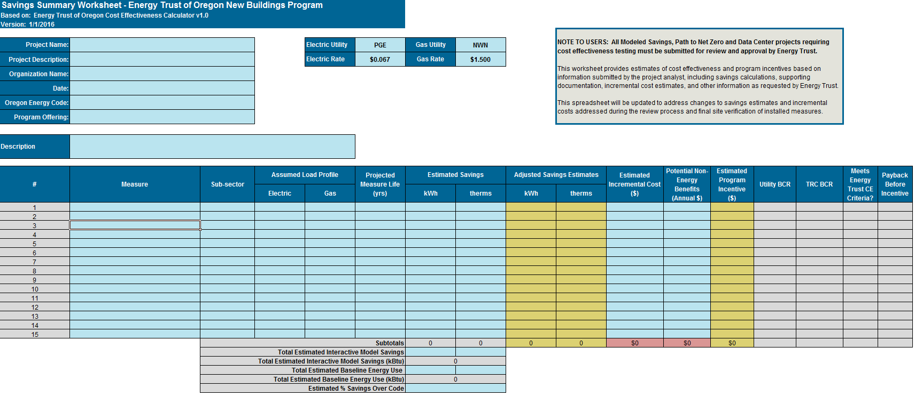

Appendix
Include all supporting calculation documentation required for the report in this section, including spreadsheet calculations, energy model report summaries, and an energy model takeoff sheet summarizing the technical inputs to the model that were either obtained from the project drawings or from the design team. Also include the equipment manufacturer’s specification cut sheets and supporting incremental cost information in this section.

A table, similar to Table A-1, must be included showing the comparison between the baseline guideline requirements and the proposed design. For projects that have performed a whole building energy analysis, the table must also indicate the baseline modeling requirements (e.g. Oregon Energy Efficiency Specialty Code, Energy Trust of Oregon New Buildings Program Technical Guidelines) compared to the proposed design.

Table A-1 – Baseline and Proposed Construction Details

